Willow Ward Induction (2017)

Welcome to Willow Ward! As the FY1 doctor, your responsibilities include:
- Reviewing patients – both for their mental and physical health; we should be seeing patients in between ward rounds. Prescribing is on paper charts (!), and the pharmacists are all very helpful. Beware that their stocks are limited, so if you are going to prescribe something not normally stocked, it will take a few days to arrive.
- Taking and chasing bloods (labelling your own blood bottles and forms will be your new reality), ECGs and organising investigations at Addenbrooke’s– we will have access to the Orders Only part of Epic that the CTs and SpRs don’t.
- Scribing – during ward rounds (weekly), and also discharge planning and other meetings which can occur in between.
- Writing discharge notifications and summaries. The summaries are longer than in medicine/surgery and must be sent to the consultant to approve before they are faxed to the GP.
- Supporting Denbigh ward – within reason! We are permanently understaffed, and during the working day if you are well-supported by the core trainee and a registrar, and the regular doctor at Denbigh is not there, then if Denbigh call with an urgent job then it would be good to help. But always be aware of your limitations, and that the Denbigh patients are more difficult to manage (they will often not be able to give a clear history, nor allow you to examine them). If you are the sole doctor covering both Willow and Denbigh Wards, be clear with the nurses where you will be and what you can/can’t manage to do.
This is a really excellent placement. You’ll be exposed to lots of basic psychiatry as well as the more challenging dementia patients, and the population will inevitably have lots of comorbidities that you will have to manage along with their psychiatric symptoms and side effects from medications. You will be tested in your knowledge of general medicine and general surgery too (you might be the most recently trained person to assess someone from a medical/surgical point of view), and find yourself doing a lot of calling and referring to Addenbrookes, and making orders on Epic, so it is not all that dissimilar! The art of written and verbal communication will be another thing that you’ll get a really good exposure to.
The team are really lovely and supportive – Dr Hatfield will be your clinical supervisor, and she’s excellent and will offer you an hour (at least) supervision every week where you can talk about anything you like, and also perhaps do ward-based assessments if you need. Both Drs Hatfield and Welsh also cover the crisis team, and you can go on home visits and assessments with them. You can also have taster sessions whenever you like in the different psychiatry subspecialties, and annual leave is very easy to organise – they will never say no, as long as there is a doctor on the ward, and as you are not on the on-call rota, you never have to arrange cover for yourself. Also, you do not have to work on bank holidays. It’s all very civilised and a really great learning experience, so make the most of it!

RiO reference guide
You will receive a few hours’ training on RiO, and it is quite straightforward. However, the following can be used as a reference if you get stuck.
When you sign in, this will be the first screen you see. The Inpatient Management tab is likely to be the thing you want. Clicking on the middle button as below, and then selecting ‘Wards’ will bring you to a drop down box where you can select Willow Ward or Denbigh Ward. Once you have chosen the ward you want to look at, you need to click the bed icon (bed view) or the book icon (list view) to see all the patients. I personally prefer list view because there’s less clicking.

You’ll then get a list of patients, and you can either click on their names if in list view, or if on bed view, on the bed icon next to their name and then pick ‘Case Record’ from the arrowed menu.
For every patient, you have a panel showing their demographics, and then a right hand column of the different parts of their record that you can access. [Image taken away for patient confidentiality – there is a hard copy of this guide available on the ward]
To read a regular entry by any staff member, or to enter one, choose ‘Progress Notes’ on the right hand side (‘Add new note button’ is on the bottom of the page).
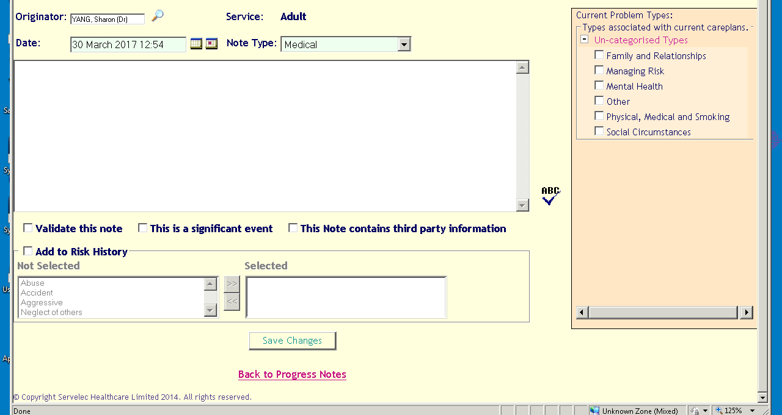
If you are happy with the note as it is, then check the ‘Validate this note’ box and save changes. If you do not validate, then you can edit and validate at a later time. If you do validate, you cannot then amend the note at all. The only change you can make to a validated note is to delete it (There is no ‘Addendum’ function as in Epic). If the entry you want to make will be very long, I would advise typing it into Word and then copying and pasting. Yours truly was stung by a very brief powercut while doing a very long entry, and I had to then do it all over again. Word has Autorecovery, RiO does not.
When you have taken bloods or requested investigations; copy and paste the results from Epic into a RiO Progress Note, and also copy and paste it into the Investigations tab on the right hand side. It should be straightforward. We used to handwrite all the blood results into a folder as well.

Ward Round Entries/CPA Reviews/MDTs
It tends to be good to prep these, i.e. book the appointments on RiO and then also draft the word doc entries on a Monday, ahead of the Weds/Thurs ward rounds.
Making the appointments:

Reviews CPA review management (at the bottom) Review (at the bottom) Schedule CPA review
You must then select duration (I usually say 30 minutes), do the date and time of the ward round, and the location will be Willow or Denbigh, then check that the consultant is invited, but then don’t worry about inputting all the MDT members individually, as you will be writing down who attended later anyway.

Documenting the MDTs:
Citrix Applications My Computer MHT Shared (drive) Older People Inpatient Services Willow Ward/Denbigh Ward MDT Dr Hatfield/Dr Welsh
In the folders you should find other folders with months, and also a blank MDT template. For a new patient, open up the template, enter in all the information at top that you can, and save that as a new file under that patient’s name. You can also save yourself some time by duplicating the doc files into the future folders if you know that the patient will likely by there in the weeks afterwards.
Once you’ve typed everything in the word doc, prepare to upload it onto RiO by doing the following:
Reviews CPA Review management Review click the green arrow on the appointment you booked earlier.
Copy and paste everything from the word document to the “Other notes” box, then:
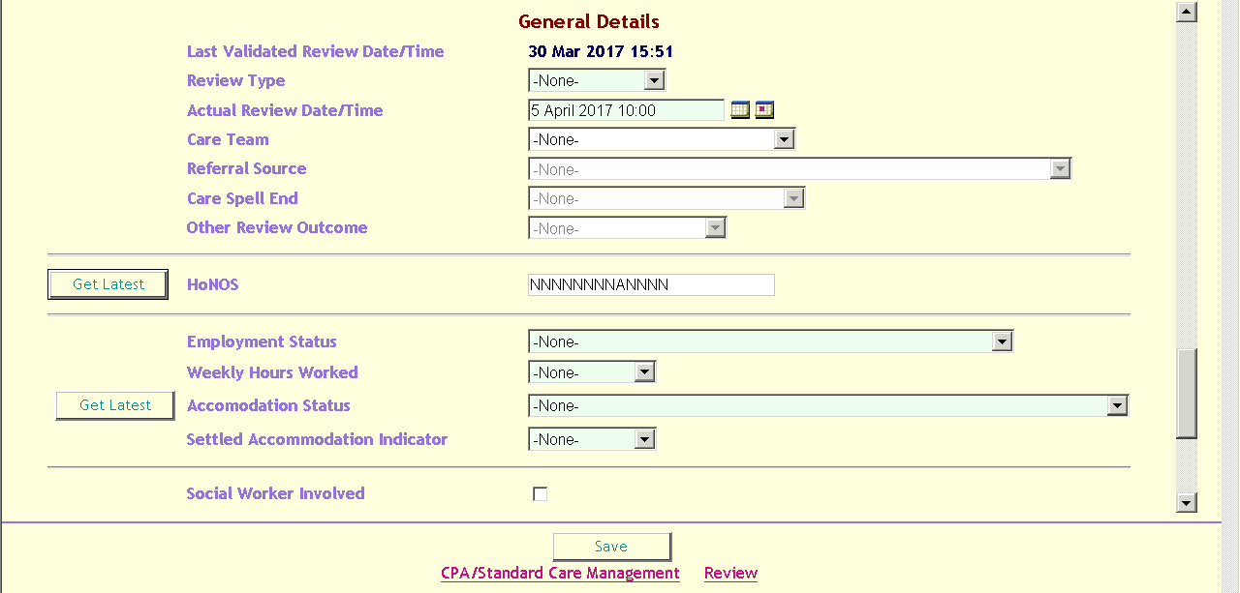
Review type – select ‘Other review’; Care team – select Willow OP or Denbigh OP
Other review outcome – select ‘Follow-up’. Then press ‘Get latest’ under the Employment Status etc. If it has not already been pre-entered for the patient (it usually is) then you’ll have to do each individually. Once you’ve completed all of that, check ‘validate’ and then save. Bosh.

Admitting patients:
Rarely happens in the working day, it is usually done by the Duty Doctor out of hours. However, if you have to, then go and interview them, examine them, do the ECG and bloods (if they’re willing), and then input all of that information in RiO.

On that right hand panel:
Assessments Core Assessment Core Assessment v2. Then complete the form as best you can, but you can leave the Capacity, Safeguarding and Risk and the Social Circumstances and Employment tabs for the nurses to complete.
Please do not forget to choose the referral on the drop-down box. It will be the one which has the date the patient has arrived/been referred to the team, and it will be Willow OP or Denbigh OP under the Service/Team.

For the physical examination stuff:
Assessments Physical examination and Health Check. Complete the Part A (V2) form and the VTE risk assessment forms. If the patient refuses then complete the refusal form.

There is a laminated checklist on the desk that tells you everything that must be done for any new patient. ACE-III can wait until they’re more stable, but everything else should ideally be done within 24 hours of their arriving o the ward.

Discharging patients:
On that right hand panel:
Discharge Discharge from Inpatient Care Notification
Then fill out the form as best you can – this will contain the TTOs, and the plan moving forward. Make sure you ask who the care coordinator will be, and which community team, whether that is the Crisis Team or the Neighbourhood Team, will be doing the 7 day follow-up. When you have completed and saved it, you have the option of printing it out if you go right to the end and click the link near the bottom of the saved form that reads ‘Discharge Notification Report’. Print, sign, and give it to the nurses to pass on to pharmacy to check and then fax to GP.

If you go to the Willow Ward folder Discharge summaries, there should be template discharge summary forms. Fill the entire form – the past history etc can be copied and pasted from the Core Assessment, and you can write the record of their time on the ward, and also include the results of key investigations. Once you have done as much as you can, email it to Dr Hatfield/Dr Welsh, and they will read and amend and send it back to you.

Then, print the final copy, sign it and give it to the ward clerk to fax to GP and upload into the scanned documents on RiO. It would also be good practice to complete the Discharge Summary from Inpatient Care tab on the Discharge menu (where you sent the notification), which will just be copying and pasting into the relevant boxes.

There is a notebook in which we tend to write our jobs for every day. It would be good practice to complete the SHO list (folder called SHO lists in Willow Ward folder) and update it, but I have let it lapse for a while because we primarily use the book and I often don’t have time. Duty doctors will look at it and find it useful, but if you email a handover to them with enough clinical information, they should be happy.

…I think that’s everything. For everything else, ask the Core Trainee!

I hope you enjoy your placement – I genuinely am considering psychiatry as a career after this, and I hope this was a helpful guide.

Sharon Yang, FY1 in 2017.

